Programming Assignment 1
Deadline: 5th November 2020

Background
In computer graphics, it is convenient to render the scene with the camera at the origin and pointed in the negative z-direction. However, we want to be able to position the camera anywhere and render the scene. This means that we must transform from "world" coordinates to "camera" (or "eye") coordinates. To accomplish this, the user must provide 3 pieces of information (read in from an input file, refer to the example figure):
- the location (x,y,z) of the camera in "world" coordinates (eye point, E)
- the location (x,y,z) that the camera is pointed at (at point, A)
- the direction (x,y,z) that is "up" for the camera (up vector, v_up)
After obtaining the three coordinates for one of the above items, repeat the input in the form of an ordered triplet (x, y, z).
Using these supplied values, it is possible to construct a coordinate system where the camera is pointed along one of the coordinate axes. Then we can take all of our objects in world coordinates and transform them into camera coordinates. Instead of (x,y,z), the camera coordinates are usually labeled (u,v,n).
Computing n
The view normal (n) is easily obtained through point-point subtraction. Simply subtract the at point from the eye point (E - A) coordinate by coordinate. This is the direction along which the camera is pointed. Note that the camera is pointed in the negative n-direction.

Computing v
You may skip this detailed explanation

Obtaining v is more complex. First, v must be in the same plane as n and the up vector. This means that it is a linear combination of n and v_up which we can write as:
v = α*n + β*v_up
In addition, v must be orthogonal (at a right angle) to n (just as x, y, and z are all orthogonal to one another). We can use the dot product to enforce this requirement.
a.b (a dot b) = a_x*b_x + a_y*b_y + a_z*b_z (an obvious candidate for a macro)
where a_x is the first component of a, etc.
note: the dot product is just a number, a scalar
If two vectors are orthogonal, then their dot product is 0. Let's take the dot product of our formula for v with n:
0 = α*(n.n) + β*(v_up.n), which means that (solving for α and substituting)
(n.n)v = -β(v_up.n)n + β(n.n)v_up
To find (n.n)v, you will need to perform vector-scalar multiplication and vector_vector addition. First, you need to compute -β(v_up.n), which is just a scalar. Then, multiply this scalar by each component of n to obtain each component of -β(v_up.n)n. Now, add the components of -β(v_up.n)n and β(n.n)v_up together, component-by-component, to obtain (n.n)v.
I have multiplied v through by n.n (again, just a number) so that I can avoid doing division. When doing any integer arithmetic, we want to do the division last so that the rounding error involved in division does not accumulate with each subsequent arithmetic operation. This will not affect my answer as multiplying a vector by a scalar changes its length, but not its direction. In fact, since we are not concerned with the length of v, just its direction, we can set (n.n)/β = 1.

v = -(v_up.n)n + (n.n)v_up

Computing u
The last vector in our new coordinate system is u. It is obtained simply by noting that it must be orthogonal to both v and n. We can use the cross product to obtain u. The cross product of two vectors gives a third vector orthogonal to the first two. Note that you will actually obtain (n.n)u, but again, this is okay.
Compute u using v x n.
a x b (a cross b) =
a_y*b_z - a_z*b_y (the first component of a x b)
a_z*b_x - a_x*b_z (the second component of a x b)
a_x*b_y - a_y*b_x (the third component of a x b)

Normalization
For the transformation to camera-coordinates to work correctly, the lengths of each of our 3 vectors must be 1. The dot product can be used to obtain the length of a vector:
a_len = √a.a
To normalize a vector, simply divide each component of the vector by the length of the vector.
https://chortle.ccsu.edu/vectorlessons/vch08/vch08_2.html

Use the provided batch file (camera_build.bat) to assemble and link your program. Your program must work with this build file. Put header files (io.h, debug.h, sqrt.h) in the Assembly directory. This will make it much easier for me to grade your programs.
Your program must work with an input file (camera_input.txt) and have output formatted as in the below figures:

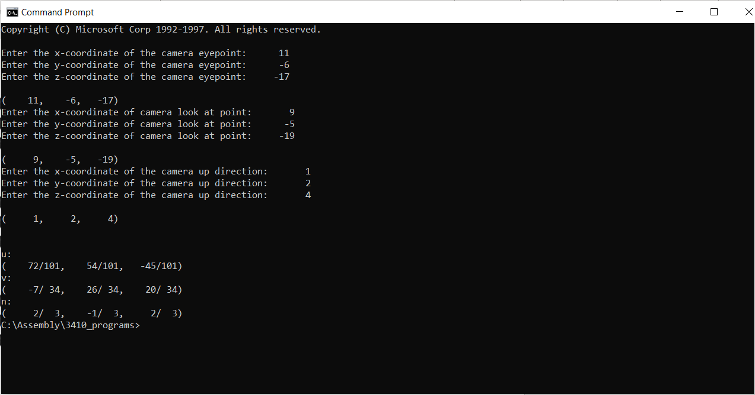

Program Specification:
Compiling, Linking, Running
Basic I/O (using io.h)
  - Obtaining user input
  - Using an input file
  - Displaying computation results
Data Types
  - WORD
  - BYTE
Basic Instructions and Computations
  - Move
  - Add
  - Subtract
  - Multiply
Write Numerous Macros
  - Computation Macros
  - Display Macros

Submission (Submit on iLearn)
- camera.asm

For more information on the principles of the camera structure and what this solution is trying to solve a this link will provide more information: http://learnwebgl.brown37.net/07_cameras/camera_introduction.html

Expectation for the program in more general terms to help if the problem statement above was not clear.

- You will write macros to solve the problems listed above further explanation is included below to help if needed.
  - Dot Product – This will be equivalent to x1 * x2 + y1 * y2 + z1 * z2
  - Cross Product.- This one is posted above in the documentation and when it states first component it means the x, second component is y, and the third component is the z for the cross product.
  - Normalization – This will use the vector length macro. The square root of the dot product is equal to the length of the vector and to normalize each part of the coordinate will be divided by the length. {x1 / length, y1 / length, z1 / length}
  - vector_length – this is a macro that will use the dot product to find the vector length. The vector length is the square root of the dot product.
  - Point_subtract – this does point to point subtraction. This means coordinate_1 – coordinate_2 = { x1 – x2, y1 – y2, z1 - z2 }
  - Point_vector_add – similar to above but addition
  - macro_for_IO – will call the macro_for_Coordinate to populate input as appropriate
  - macro_for_Coordinate – will output a prompt and read in input. Look at io.h for how to do input or output.
  - Print_Macros – will output the point as described in the macro name. Remember that to do output a word without using debug.h it has to be turned into a byte array using itoa.
- The macros listed above will be used to solve the problems listed in the program description. Remember to test often also make sure that the correct coordinates are being used for the calculations for n, v, and u calculations. Using the wrong coordinates for the problems will result in incorrect answers.
- Formatting does matter for the coordinate printing. Hint this can be done by adding them to a byte array using offsets from the start to set up the correct spacing.

Hints

a x b (a cross product b)
a_y*b_z - a_z*b_y (the first component of a x b in X direction)
a_z*b_x - a_x*b_z (the second component of a x b in Y direction)
a_x*b_y - a_y*b_x (the third component of a x b in Z direction)

a . b (a dot product b)

a . b (a dot product b) = a_x*b_x + a_y*b_y + a_z*b_z
Similarly,
n . n (n dot product n) = n_x*n_x + n_y*n_y + n_z*n_z

How to implement v = -(vup.n)n + (n.n)vup

-(vup.n)n
- Calculate the dot product of vup and n.
vup_x*n_x + vup_y*n_y + vup_z*n_z

- Negate the result of step 1.
- Multiply the result of step 2 by n_x, n_y and n_z. The result will have 3 components in 3 directions (i.e. in X, Y and Z directions)
(n.n)vup
- Calculate the dot product of n and n.

n_x*n_x + n_y*n_y + n_z*n_z

- Multiply the result of step 4 by vup_x, vup _y and vup_z. Again, the result will have 3 components in 3 directions (i.e. in X, Y and Z directions) like step 3.

Finally, calculate the v
v_x = X component of result in step 3 + X component of result in step 5
v_y = Y component of result in step 3 + Y component of result in step 5
v_z = Z component of result in step 3 + Z component of result in step 5

